**MOTION FOR PAL COLLECTIVE STRUCTURE**

**The purpose of this document is to propose a motion to adopt a new structure for the PAL Collective to meet the demands of a rapidly growing community.**

**Background:** The PAL Collective in its first four months has operated very organically in a mostly decentralized, somewhat chaotic way with decision making taken both independently as well as through consensus.l keeping Gazan needs as the informant of direction.

As the PAL grows however this system will no longer serve to meet the needs for large-scale clarity, efficiency, safety and consistency. What must remain constant, is the focus on Gaza and the needs of Gazans. What must change is the scale of our impact, our ability to distribute workload, and the absence of clarity on method.

We propose to test the following structure for the next 8 weeks. Should this work, we keep/refine it, should it not work, we pivot.

Success Criteria will include:

1. Increase the number of families we steward ( 2 or 3 x the number of families we steward now? )
2. Increase in the number of active on the ground relationships that we have built to solve problems (like with merchants and aid organizations/field operations to reach more families
3. Safety of our collective (how can we measure this)
4. Regular communication cadences and transparency in the impact- like publishing updates on our website or somewhere

**Method**

Through interconnected semi-independent initiatives with co-leads focused on mobilizing resources within a group around solving Gaza problems.

By maintaining the semi-autonomy, we allow for organic, expertise-focused ideation (e.g the Medical professionals group don’t need advice on how to set up a telehealth service. Similarly the mental health and wellness group have the skills and experience to organize their resources to meet the PAL’s need to support themselves and Gazans.

Therefore the structure we propose is as such:

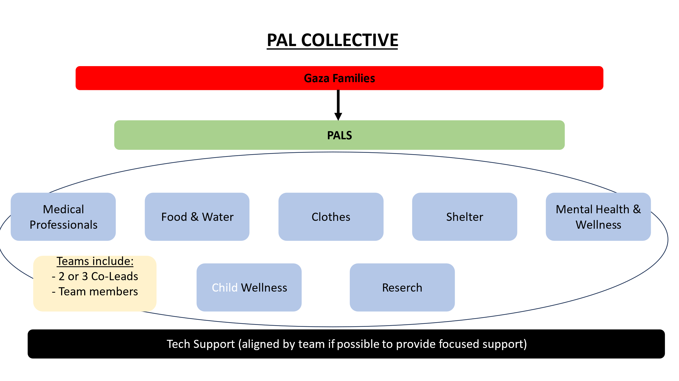

* We have groups based on core skills or initiatives (Food, Shelter, Clothes, Fundraising etc).
* Members of the Collective voluntarily join groups that align with their skills and interests.

**Each group has:**

* 2 or 3 co-leads
* the co-leads are responsible for understanding the needs of the PALs/Gazans (what problems need to be solved) and then organizing the skills and resources within the group in whatever they see most fit to meet those needs.

The co-leads are talented and experienced in their field and do not need to be micro-managed. They simply need to abide by :

* the Pal Collective mission and values
* The Pal Collective code of ethics and safety protocol
* Ensure that focus is always on the priories of Gaza as reflected by the Pals  (from Gazans)

**Managing communication and transparency**

To enable the power of the collective we need to harness communication through a cadence of regularly scheduled meetings.

* Every group sends 1 representative to the Weekly Leaders Update Meeting.
* The agenda during the meeting is :
  + Update from Gaza families through Pals (what are dominant needs, what’s happened on the ground in Gaza, challenging requests etc)
  + update from every group leader on progress or cases solved, issues, failures, challenges
* Every group gets 5–7 mins to share unless there is a problem to solve.
* Team Leads host their own meetings as and when they need to. They are autonomous.
* Decisions are made by presenting a motion and the group votes on that. We can determine details of the voting system used later.

The PAL Collective in its first four months has operated very organically in a mostly decentralized, somewhat chaotic way with decision making taken both independently as well as through consensus keeping Gazan needs as the informant of direction.

As the PAL grows however this system will no longer serve to meet the needs for large-scale clarity, efficiency, safety and consistency. What must remain constant, is the focus on Gaza and the needs of Gazans. What must change is the scale of our impact, our ability to distribute workload, and the absence of clarity on method.

We propose to test the following structure for the next 8 weeks. Should this work, we keep/refine it, should it not work, we pivot.

**Success Criteria will include:**

1. Increase the number of families we steward (2 or 3 x the number of families we steward now? )
2. Increase in the number of active on the ground relationships that we have built to solve problems (like with merchants and aid organizations/field operations to reach more families
3. Safety of our collective (how can we measure this)
4. Regular communication cadences and transparency in the impact- like publishing updates on our website or somewhere